# Assignment 01 - ICT 1123 System Analysis Design and Usability

## Group 02

1. Joseph Rasanjana – TG/2019/525
2. Umeen Rathnayake – TG/2019/516
3. Niraj Dilshan – TG/2019/491
4. Waruna Dissanayake – TG/2019/515

## System Interfaces



Figure 1: ACSS Welcome Screen

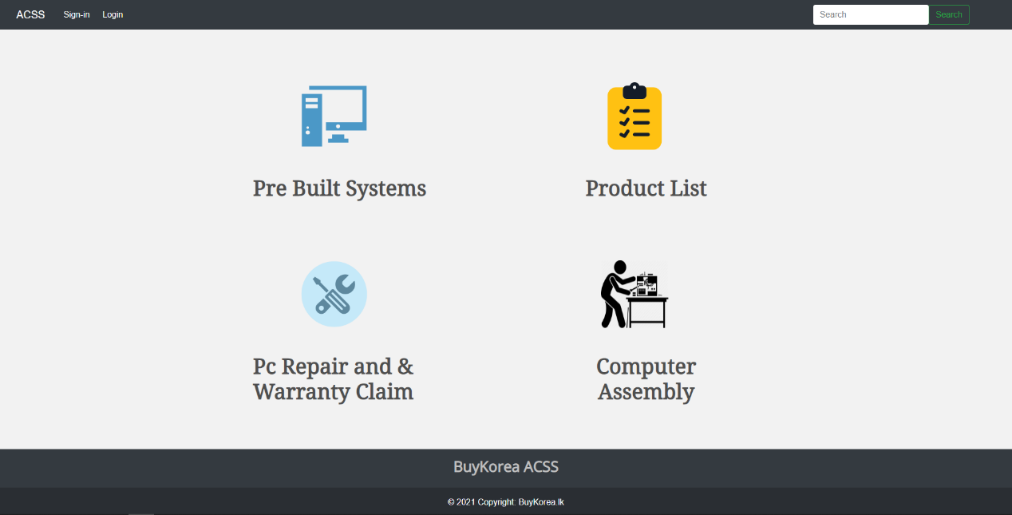

Figure 2: ACSS Home Page

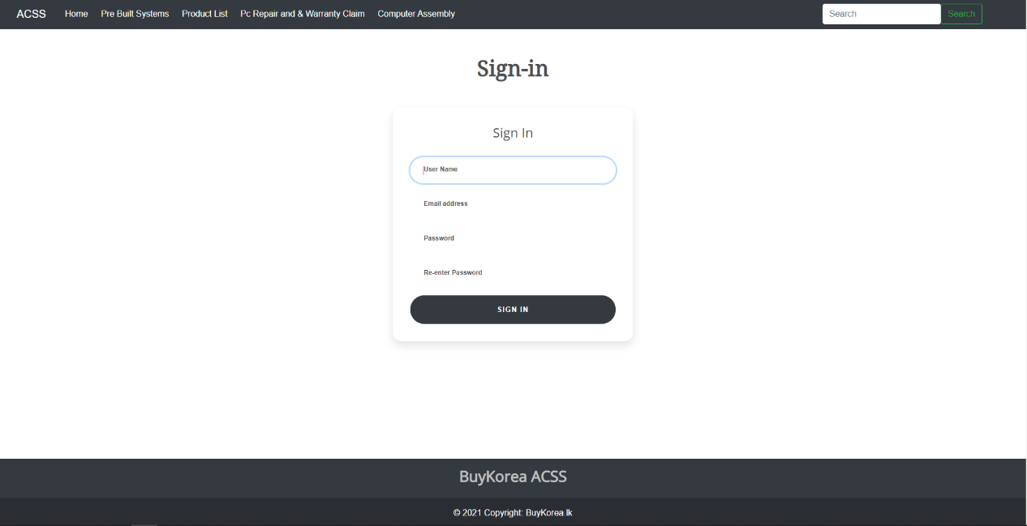

Figure 3: ACSS Sign-in Page

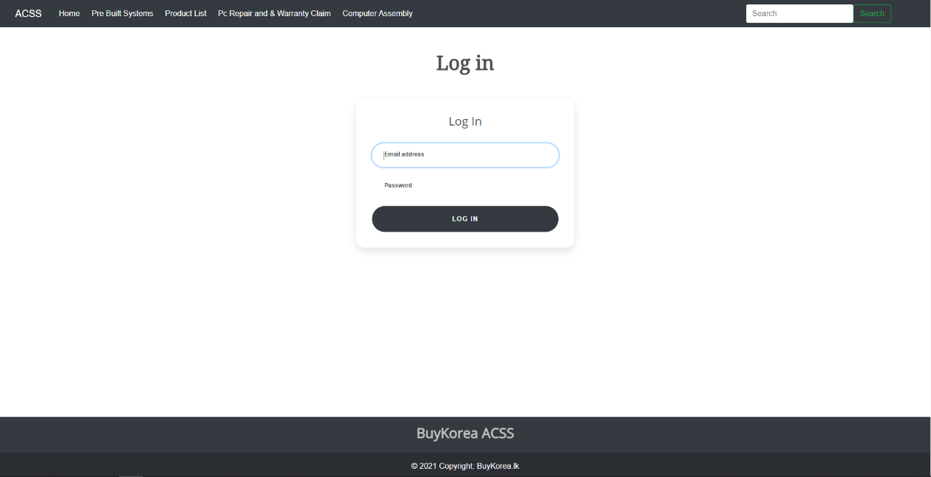

Figure 4: ACSS Login Page

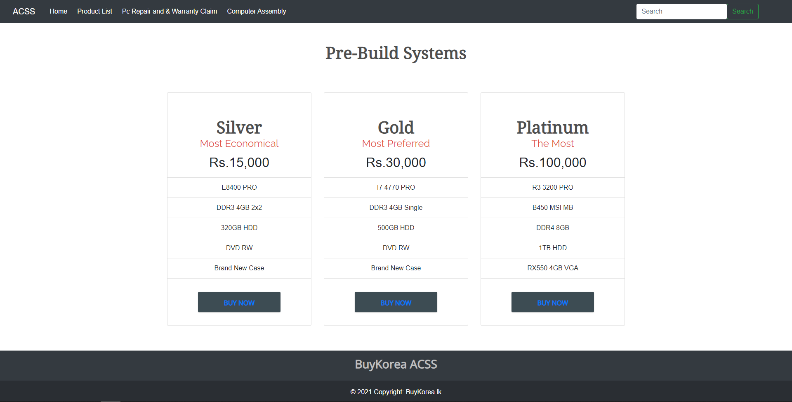

Figure 5: ACSS Pre-Build Systems Page

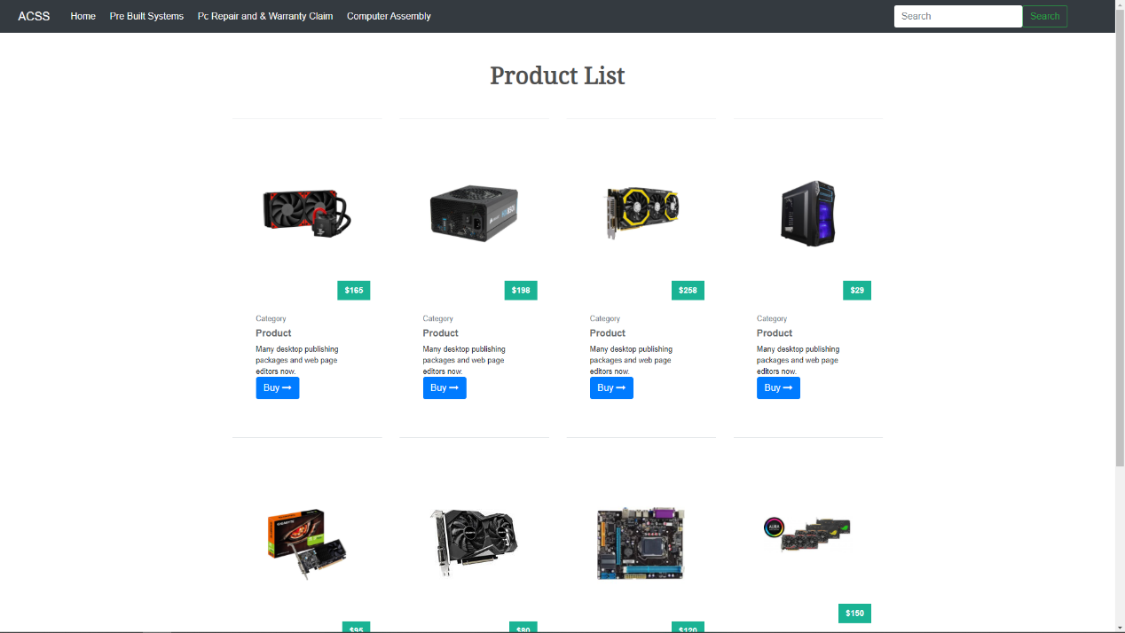

Figure 6: ACSS Product List Page

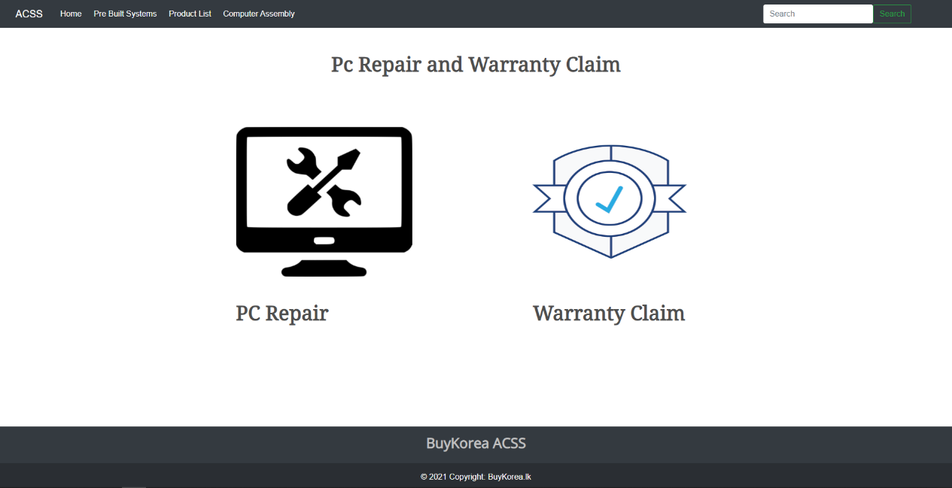

Figure 7: ACSS Repair and Warranty Choose Page

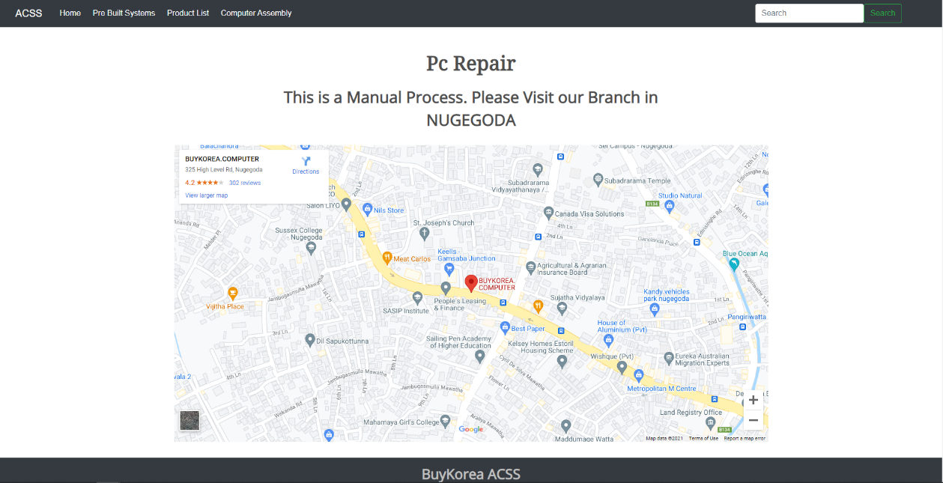

Figure 8: ACSS PC Repair Page

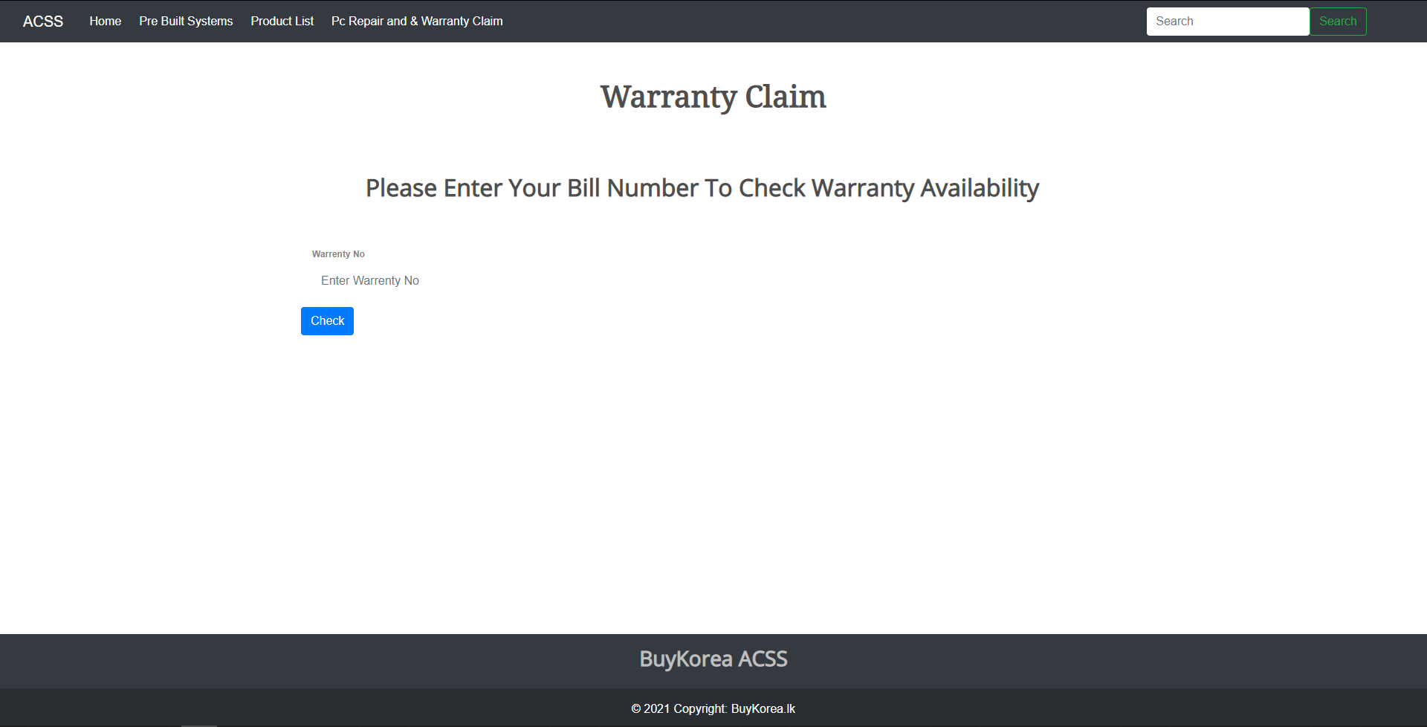

Figure 9: ACSS Warranty Claim Page

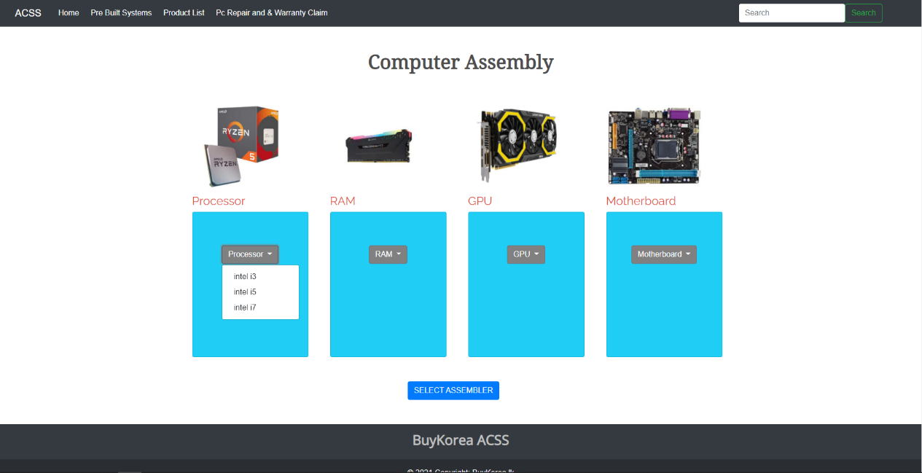

Figure 10: ACSS Computer Assembly Page

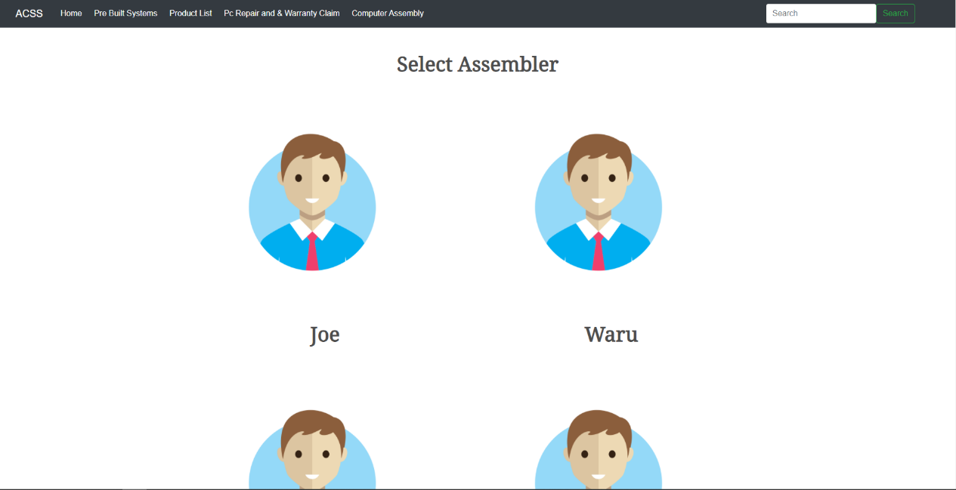

Figure 11: ACSS Select Assembler Page

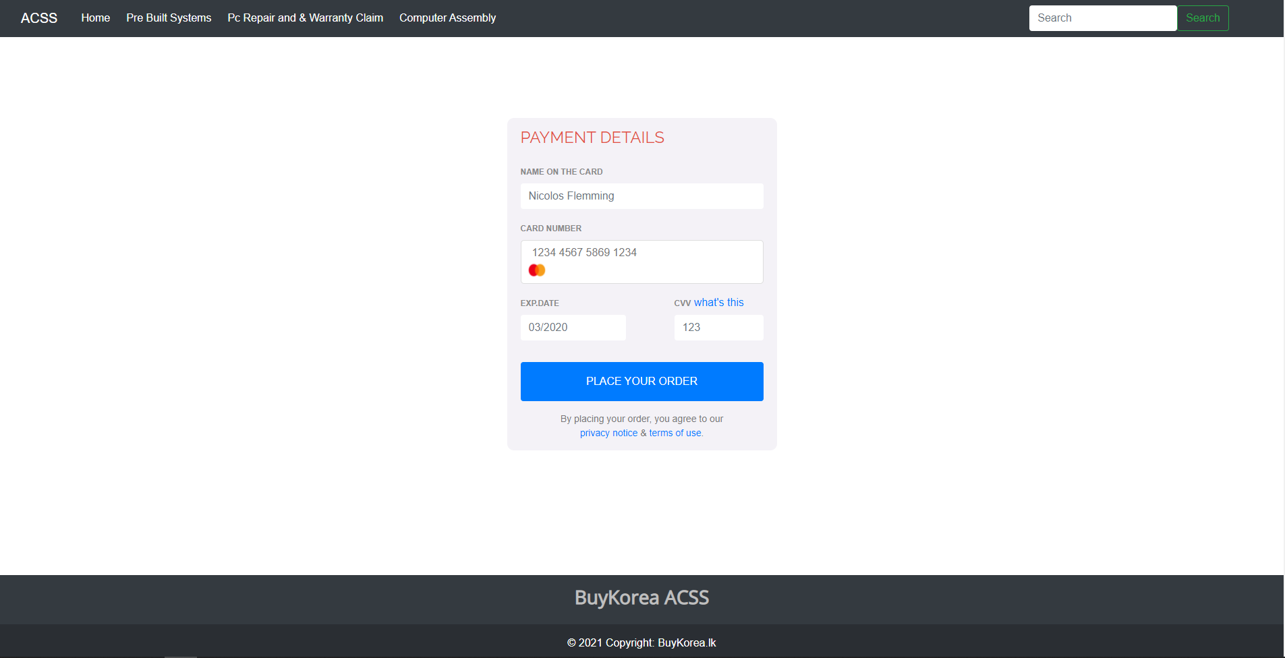

Figure 12: ACSS Payment Portal

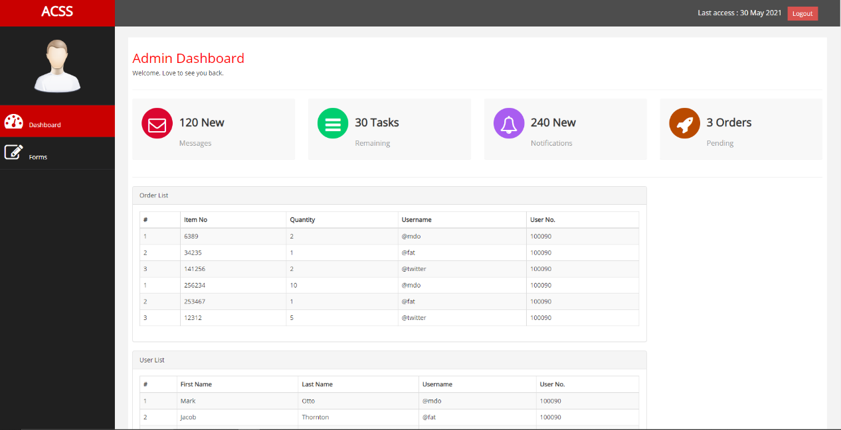

Figure : Admin Dashboard

**"ACSS - Automated Computer Shopping System" folder contains the web-based project. Please run the ACSS.html file.**